**PROJECT DOCUMENTATION**

**Fitflex:Your Personal Fitness Companion**

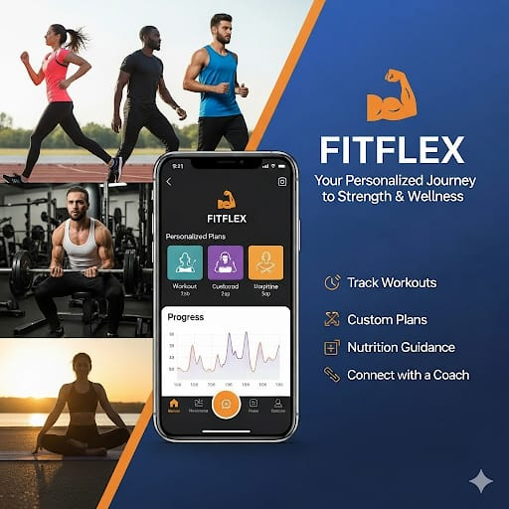

**PROJECT TITLE: Fitflex: Your Personal Fitness Companion**

**TEAM ID: NM2025TMID36507**

**TEAM LEADER:**

* **MADHUMITA.S –** [**24csmadhumita050@gmail.com**](mailto:24csmadhumita050@gmail.com)

**TEAM MEMBERS**

* **LOSHINI.A –** [**24csloshini049@gmail.com**](mailto:24csloshini049@gmail.com)
* **LAVANYA.S –** [**24cslavanya048@gmail.com**](mailto:24cslavanya048@gmail.com)
* **LAKSHMI.R –** [**24cslakshmi047@gmail.com**](mailto:24cslakshmi047@gmail.com)

**Introduction:**

* Welcome to the forefront of fitness exploration with SB Fitzz! Our innovative fitness app is meticulously designed to revolutionize the way you engage with exercise routines, catering to the diverse interests of both fitness enthusiasts and seasoned workout professionals. With a focus on an intuitive user interface and a comprehensive feature set, SB Fitzz is set to redefine the entire fitness discovery and exercise experience.
* Crafted with a commitment to user-friendly aesthetics, SB Fitzz immerses users in an unparalleled fitness journey. Effortlessly navigate through a wide array of exercise categories with features like dynamic search, bringing you the latest and most effective workouts from the fitness world.
* From those embarking on their fitness journey to seasoned workout aficionados, SB Fitzz embraces a diverse audience, fostering a dynamic community united by a shared passion for a healthy lifestyle. Our vision is to reshape how users interact with fitness, presenting a platform that not only provides effective exercise routines but also encourages collaboration and sharing within the vibrant fitness community.
* Embark on this fitness adventure with us, where innovation seamlessly intertwines with established exercise principles. Every tap within SB Fitzz propels you closer to a realm of diverse workouts and wellness perspectives. Join us and experience the evolution of fitness engagement, where each feature is meticulously crafted to offer a glimpse into the future of a healthier you.
* Elevate your fitness exploration with SB Fitzz, where every exercise becomes a gateway to a world of wellness waiting to be discovered and embraced. Trust SB Fitzz to be your reliable companion on the journey to staying connected with a fit and active lifestyle.

**Project Goals and Objectives:**

The primary goals of the **Fitflex** application are to empower users to lead a healthier and more active lifestyle by leveraging and technology. The website is designed to be intuitive data-driven, and personalized to cater to user’s fitness needs. The goals of the project are:

* **Promote Health and Wellness**

Provide users with tools to monitor and improve their physical fitness

through tailored workout and nutrition plans.

* **Encourage Consistency**

Help users stay motivated by setting achievable goals, tracking progress,

and sending timely reminders.

* **Personalized Fitness Experience**

Offer customized workout routines and dietary suggestions based on

individual health metrics such as age, weight, and fitness goals.

* **Community Engagement**

Foster a supportive environment where users can connect with friends,

share achievements, and stay inspired throughout their fitness journey.

* **Data-Driven Insights**

Provide users with analytics and feedback to better understand their

health patterns and make informed decisions to enhance their well-being.

* **Accessibility and Ease of Use**

Ensure the app is user-friendly and accessible to a wide range of users

regardless of their fitness level or technical expertise.

**Project Objectives**

The objectives are specific, measurable targets that guide the development and functionality of the FitFlex application:

* Develop a Comprehensive User Registration and Profile Management System

Allow users to create accounts, input personal data, and update fitness

goals in a secure and seamless manner.

* Design an Intuitive User Interface (UI)

Create an interactive, responsive interface that provides easy navigation

through workouts, diet plans, and progress tracking features.

* Implement Workout Tracking and Recommendations

Offer categorized workouts and generate suggestions based on user

preferences, available time, and fitness goals.

* Provide Real-Time Progress Monitoring

Enable users to track metrics such as steps taken, calories burned, and

workout duration through live feedback and performance summaries.

* Integrate Goal Setting and Notifications

Support users in defining short-term and long-term fitness goals while

providing reminders and alerts to maintain discipline.

* Enable Social Interaction and Sharing

Allow users to connect with friends, share their achievements, and

participate in challenges to boost engagement.

* Ensure Data Security and Privacy

Protect user data through encryption and secure storage while adhering

to best practices for data protection.

* Create Offline and Online Functionality

Provide core features that function even without continuous internet

access, while syncing data once the connection is restored

**Overview**

FitFlex is designed to help users lead a healthier lifestyle by providing personalized fitness plans, tracking tools, and community support. The application is equipped with a range of features that are simple, efficient, and tailored to meet individual needs. These features aim to guide users through their fitness journey by providing motivation, structure, and insights.

**Key Features**

**User Registration and Profile Setup**

* Secure user account creation with email and password authentication.
* Profile customization with personal details such as age, weight, height, and fitness goals.
* Option to upload a profile picture for personalization.

**Workout Library**

* A wide variety of workouts categorized into Strength, Cardio, Yoga, and Stretching.
* Workouts are designed to suit different fitness levels from beginners to advanced users.
* Video and text-based guides for each exercise with step-by-step instructions.

**Nutrition and Diet Guidance**

* Customized meal plans based on fitness objectives like weight loss, muscle gain, or endurance building.
* Recommendations on calorie intake and portion sizes.
* Tips on balanced diets, hydration, and healthy eating habits.

**Progress Tracking**

* Daily tracking of steps, calories burned, workout duration, and activity level.
* Graphs and summaries to monitor improvement over days, weeks, or months.
* Regular feedback to adjust workout intensity or diet plans.

**Goal Setting and Reminders**

* Set short-term and long-term fitness targets.
* Regular reminders and notifications to keep users engaged and motivated.
* Achievements and milestones to reward progress and encourage consistency.

**Community Engagement**

* Connect with friends and family through the app.
* Share progress, achievements, and fitness challenges.
* Participate in group activities to stay accountable and inspired.

**Data Security and Privacy**

* Secure encryption methods to protect personal data.
* Clear privacy settings to manage access permissions.
* Compliance with best practices in data protection.

**Offline Functionality**

* Core tracking features available even without an internet connection.
* Auto-sync once connectivity is restored to ensure uninterrupted user experience.

**User-Friendly Interface**

* Simple, clean, and intuitive design suitable for all age groups.
* Easy navigation between workouts, progress reports, diet plans, and settings.
* Minimal learning curve, enabling users to focus on fitness without technical barriers.

**Insights and Analytics**

* Personalized reports based on user data to help make informed fitness decisions.
* Trend analysis showing activity patterns and progress over time.
* Suggestions for adjustments in routines to enhance results.

Additional Considerations

**Additional Considerations**

* Battery Usage:Tracking activities and using GPS may lead to higher battery consumption. Users are advised to charge their device before starting intensive workout sessions.
* Data Privacy:

The app requires permissions for location and activity data. Users are encouraged to review privacy settings and understand how their data is used.

* Network Reliability:

While some features like step counting may work offline, real-time syncing, video streaming, and progress updates require stable internet connectivity.

* Accessibility:

FitFlex is designed to be accessible for users with varying levels of technical experience. Clear navigation and minimal setup ensure usability across demographics.

**PRE-REQUISITES**:

Here are the key prerequisites for developing a frontend application using React.js:

* **Node.js and npm**:

Node.js is a powerful JavaScript runtime environment that allows you to run JavaScript code on the local environment. It provides a scalable and efficient platform for building network applications.

Install Node.js and npm on your development machine, as they are required to run JavaScript on the server-side.

* **React.js**:

React.js is a popular JavaScript library for building user interfaces. It enables developers to create interactive and reusable UI components, making it easier to build dynamic and responsive web applications.

Install React.js, a JavaScript library for building user interfaces.

* Create a new React app:

npx create-react-app my-react-app

Replace my-react-app with your preferred project name.

* Navigate to the project directory:

cd my-react-app

* Running the React App:

With the React app created, you can now start

the development server and see your React

application in action.

* **HTML, CSS, and JavaScript**: Basic knowledge of HTML for creating the structure of your app, CSS for styling, and JavaScript for client-side interactivity is essential.
* **Version Control**: Use Git for version control, enabling collaboration and tracking changes throughout the development process. Platforms like GitHub or Bitbucket can host your repository.

**Project structure:**

The FitFlex application is built using a modular architecture to ensure scalability, maintainability, and ease of development. The project structure is divided into logical components such as the user interface, backend services, database management, and external integrations. This structured approach allows developers to work efficiently and users to experience smooth functionality.

**Directory Structure**

fitflex/

├── backend/

│ ├── controllers/

│ ├── models/

│ ├── routes/

│ ├── services/

│ ├── config/

│ └── app.js

├── client/

│ ├── public/

│ ├── src/

│ │ ├── assets/

│ │ ├── components/

│ │ ├── pages/

│ │ ├── services/

│ │ └── App.js

├── database/

│ └── fitflex.db (or connection scripts)

├── documentation/

│ └── project-report.docx

├── tests/

│ ├── unit/

│ └── integration/

├── .env

├── package.json

├── README.md

└── fitflex.apk (for Android build)

**Detailed Structure Description**

1. Backend

The backend handles all server-side functionalities, including user authentication, workout tracking, and data storage.

controllers/ – Contains logic for handling requests and responses.

models/ – Defines data structures and schemas such as user profiles, workout records, and goals.

routes/ – Contains API endpoints for communication between the client and the server.

services/ – Includes business logic and utility functions.

config/ – Stores configuration files such as database connection and environment variables.

app.js – Entry point of the backend server application.

**Client (Frontend)**

The client side provides the user interface and interacts with the backend.

public/ – Contains static assets like icons and images.

src/assets/ – Images, fonts, and styling resources.

src/components/ – Reusable UI elements like buttons, forms, and modals.

src/pages/ – Specific screens such as login, dashboard, workouts, and profile.

src/services/ – Handles API requests and data fetching.

App.js – Main application component where routing and layout are configured.

**Database**

* The database stores user-related data and app content securely.
* Can be implemented using MongoDB, Firebase, SQLite, or any relational/non-relational database.
* Contains schemas for users, workouts, goals, and progress logs.
* Supports data queries and updates through backend services.

**Configuration Files**

.env – Environment variables such as API keys, database URIs, and secret tokens.

package.json – Lists dependencies and scripts used in both frontend and backend.

README.md – Provides basic instructions, setup steps, and usage notes.

**Documentation**

* The documentation/ folder contains the project report, diagrams, and notes.
* Screenshots, setup guides, and technical documentation are stored here for reference.

**Testing**

tests/unit/ – Contains test cases for individual components or functions.

tests/integration/ – Tests how different parts of the system work together.

**Build Files**

The final packaged version of the app, such as fitflex.apk, is generated during the build process for distribution on Android devices.

**Technologies Used**

* Frontend: React Native, HTML, CSS, JavaScript
* Backend: Node.js, Express.js
* Database: MongoDB / Firebase / SQLite

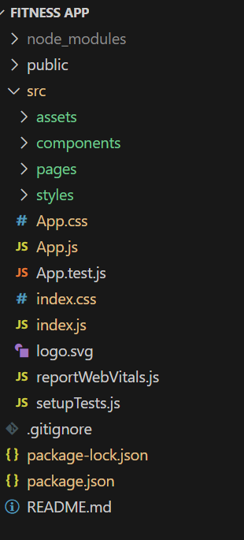 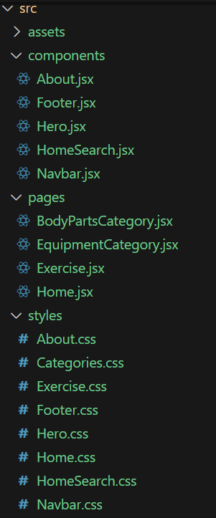

In this project, we’ve split the files into 3 major folders, *components, Pages and Styles.* In the pages folder, we store the files that acts as pages at different URLs in the application. The components folder stores all the files, that returns the small components in the application. All the styling css files will be stored in the styles folder.

**Milestone 1: Project setup and configuration.**

* **Installation of required tools**:

1. Open the project folder to install necessary tools

In this project, we use:

* React Js
* React Router Dom
* React Icons
* Bootstrap/tailwind css
* Axios

**Milestone 2: Project Development**

* Setup the Routing paths

Setup the clear routing paths to access various files in the application.

Ex:

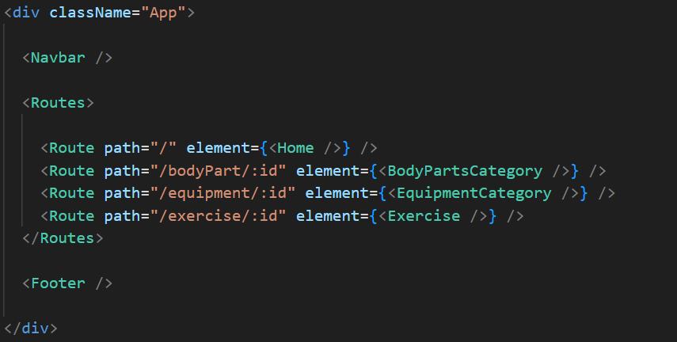

* Develop the Navbar and Hero components
* Code the popular search/categories components and fetch the categories from ***rapid Api***.
* Additionally, we can add the component to subscribe for the newsletter and the footer.
* Now, develop the category page to display various exercises under the category.
* Finally, code the exercise page, where the instructions, other details along with related videos from the YouTube will be displayed.

**Important Code snips:**

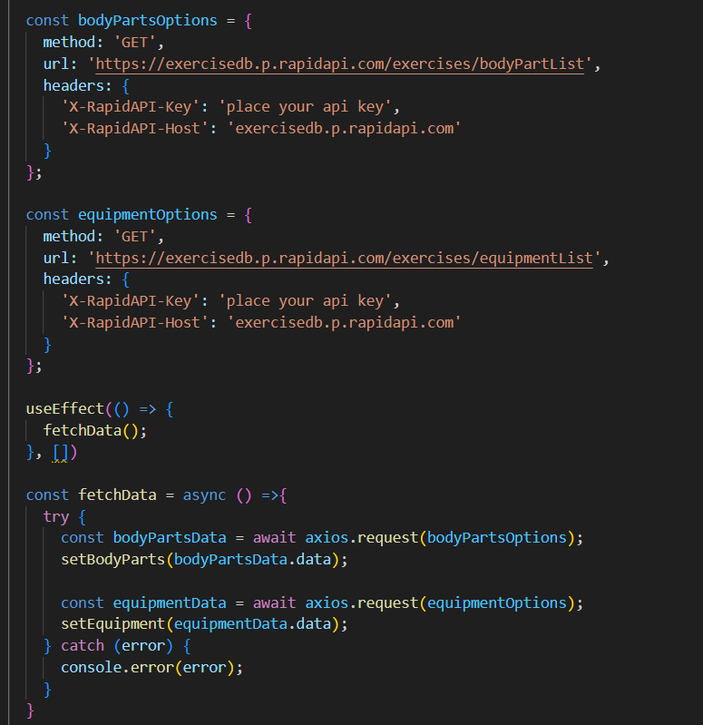

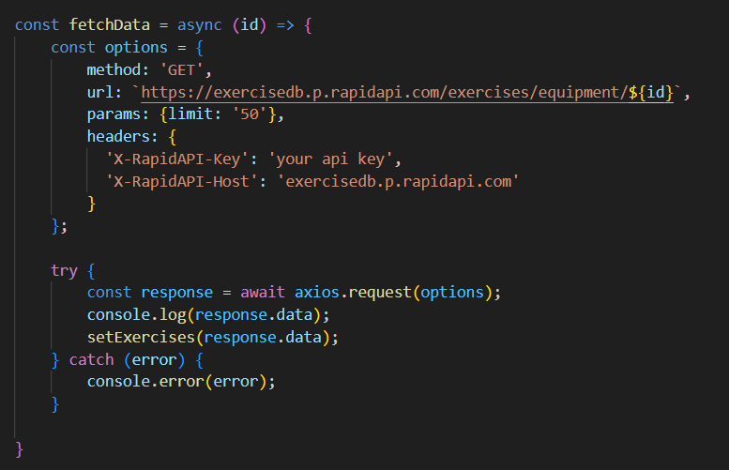

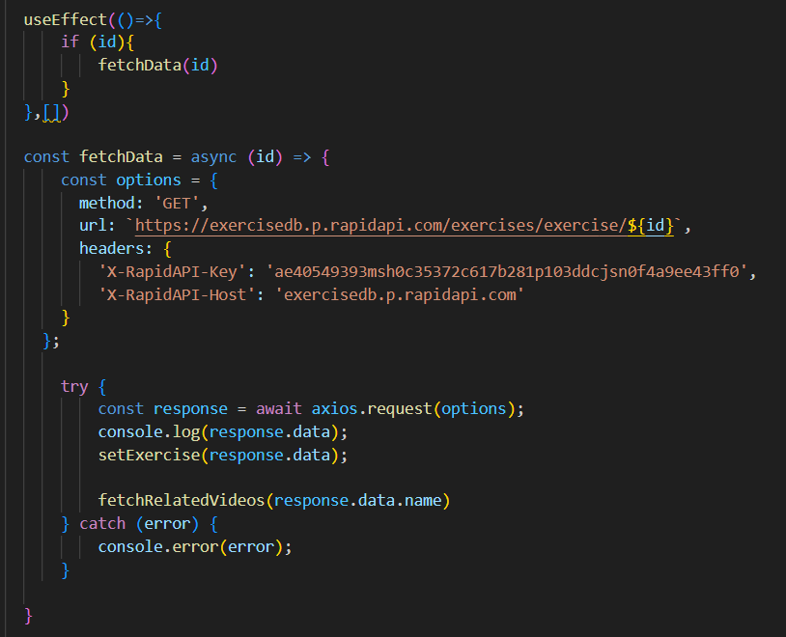

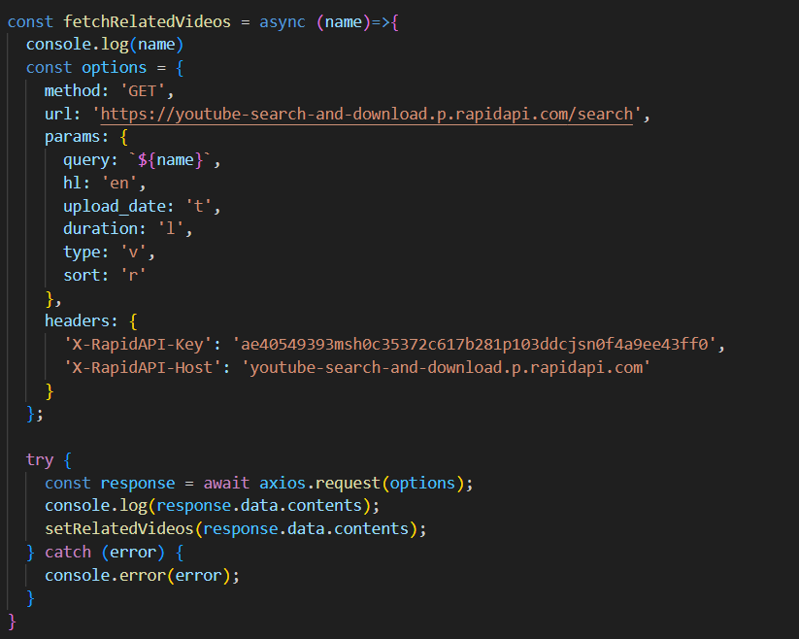

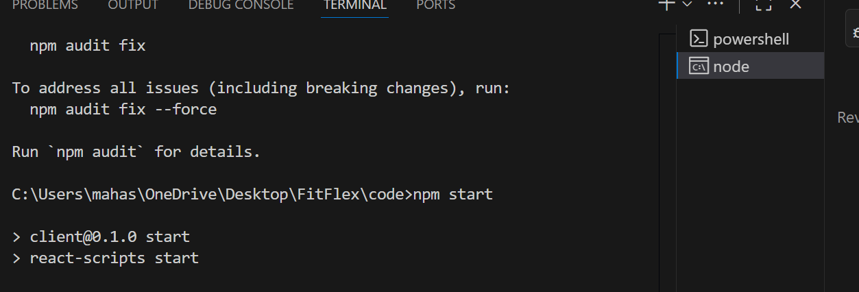

**Conclusion**

The FitFlex application is a comprehensive solution designed to support individuals in achieving their health and fitness goals through a user-friendly, interactive, and data-driven platform. By offering personalized workout routines, nutrition guidance, progress tracking, and community support, FitFlex empowers users to lead healthier and more active lives.

Throughout this project, emphasis has been placed on creating an intuitive interface, ensuring seamless integration between the client and server, and providing secure, reliable data management. The app’s features, including goal setting, real-time tracking, and notifications, encourage consistency and long-term commitment to fitness.

Moreover, FitFlex is built with scalability in mind, allowing for future enhancements such as advanced analytics, integration with wearable devices, and more personalized fitness recommendations.

In conclusion, FitFlex stands as an effective and accessible fitness companion that caters to users of all ages and experience levels. It bridges the gap between technology and wellness, offering guidance, motivation, and practical tools to help users stay on track with their health journeys. The structured architecture, thoughtful design, and focus on user experiencemake FitFlex a valuable tool for anyone aiming to improve their physical and mental well-being.